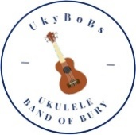
NOTES FROM UKYBOBS STEERING GROUP MEETING 2 March 2026
Attended by: Iain Harris (Chair), Lynn Watson, Jeanne Collins, Brian Sharples, Chris McAleese, Sue Earnshaw, Geoff Smithies, Mike Birtwistle.
*Review of Annual review Meeting. All agreed it was successful and well attended. The speakers presented information fully and comprehensively to members creating a clear and positive review. Some queries re Finances were answered and understood by members. The overall evening was fun socially with contributions of quizzes and games from some members.
Agenda
- Finances CMc presented a summary of our financial position. She heeded caution as expenditures we may consider, soon lead to the depletion of funds. We require a healthy cushion to ensure we can finance the requirements of running the group. Given some queries re spends/ outgoings from members it was agreed we would include the financial summaries / position on the Members page of our website. Action Mike B . We also acknowledged that the minutes from the steering gp go on website and they contain finance summary.

Finance update for February:

Balance: £5417.96
Of which £495 are donations.

Donations: £40.00 Priory
£50.00 Brookdale

Payments: £75.90 Domain hosting (annual fee)
£80 Rent
£30 Tea Coffee etc

Membership is currently 51 paid members.

Discussion of purchasing a Sum Up machine to use at charity raising events. At a cost of £60.62 for machine plus terminal. They take 1.69% of monies taken. Discussion of need for WI FI and use of hot spots on mobiles. Agreed to go ahead and purchase. Action CMc .
- Membership and Venue. Agreed BMS is perfect for our requirements with capacity to grow. Also great for future networking/ musical development opportunities with them.
Membership is currently 51 with everyone paid up. 19 pay on monthly basis. Agreed we have room for more members and will actively encourage.
The drawback of increasing members is enabling involvement in Gigs as some venues have limited capacity. We acknowledged that some just want to come along to the practices and not take part in gigs. The system we use does try and make it fair and equal where possible.
UPDATE: A reminder re. ‘Overbooking’ was given at Tuesdays session.
- Gigs/ Events. Lynn continues to manage this. Bookings are steadily coming in. Many are repeat bookings. A new booking for Band on the Wall 7 July as a joint venture with BMS who are showcasing their projects and invited Ukybobs.
Discussion of possible opportunity to link with BMS choir for some coaching on singing. But agreed we do 2-part harmonies and backing singing at the most.
Lynn expressed concern about people overbooking onto gigs and the challenges of this to manage. The system won't stop at full capacity and we can't take the poll down. Agreed we need to remind people to look at the numbers required, and places booked already, prior to booking.
- Music / Equipment. Geoff stated we have most of equipment we need now. Headset Mics being trialled and seem to work better than others and create less clutter with mic stands.
We still need our own mics at gigs as dynamic mics in situ tend to only pick up those on the mic and not the surround sound. Needed for gigs such as Prestwich, Glaston-Bury. We have 4 x Condenser Mics, and 2 dynamics and one for Cahon. Worked well for Santa Dash event at Burrs where everyone participating could hear us playing and it spurred them on!
Both Cahons are becoming worn. Agreed to buy another without a built-in mic. Also not to use sticks on drum. Brushes or hands better for health of drum.
- IT. Mike keeping great oversight of usage. See attached summary. Annual subscription paid for website server.
- Safeguarding. JC has sign up of policy from most members. Just some to chase up.
- AOB
Geoff shared publicity for Bury Times for approval of wording and other suggestions following our donation to BMS. BMS are submitting to Bury Times with a photo of us all together.
UPDATE: We made it into BT on 4/3/2026 as a news item!

Recording Studio experience – Iain discussed opportunity to go to a recording studio as a new experience for the group. Cost is quite high, 8 tracks approx. £800. Decided to put to group on Tuesday to seek appetite for it, then further consider options.
UPDATE: There was enough interest from the group on Tuesday to go forward with this.

Hoylake. To seek interest from group as to transport requirements, whether people going for day/ weekend. IH
UPDATE: There was also enough interest from the group on Tuesday to go ahead with this.

Glaston-Bury. Application being submitted. Depending on response to this e.g. where we will be situated etc will determine if we go ahead.

Leaflets.
Brian has leaflets. Agreed to keep same without photo as it changes over time. For distribution and publicity uses at Festivals etc
Weavers Uprising / Ellen Strange events tbc.

Back to Basics at Welcome Inn tba. 15th April 2pm til 4 pm. Posters to be displayed in pub. Tony Mc to see if available and book.
Hare and Hounds brewery Sunday 7th June. 3.30pm to 5.15pm

Summer Social at Coach and Horses. ‘Fun Strum’ in the Sun!
24th June from 4 pm. Coach to be booked. Brian.

Next Meeting tbc.
Website Stats Year to Date 1st March 2026
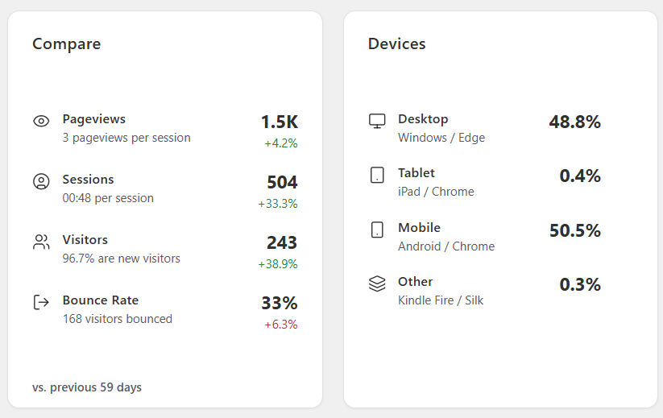

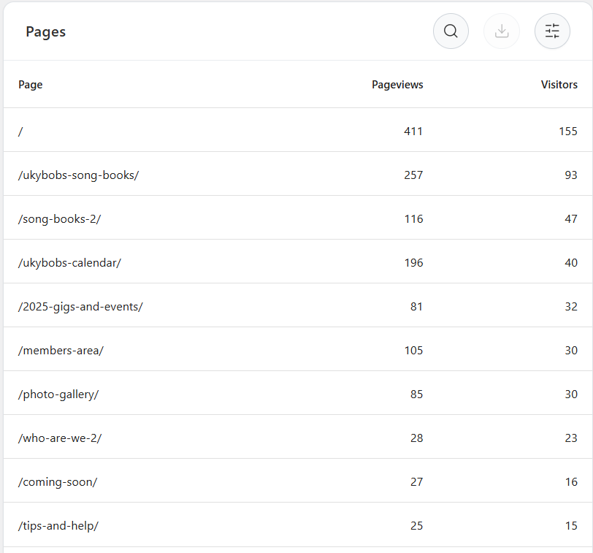
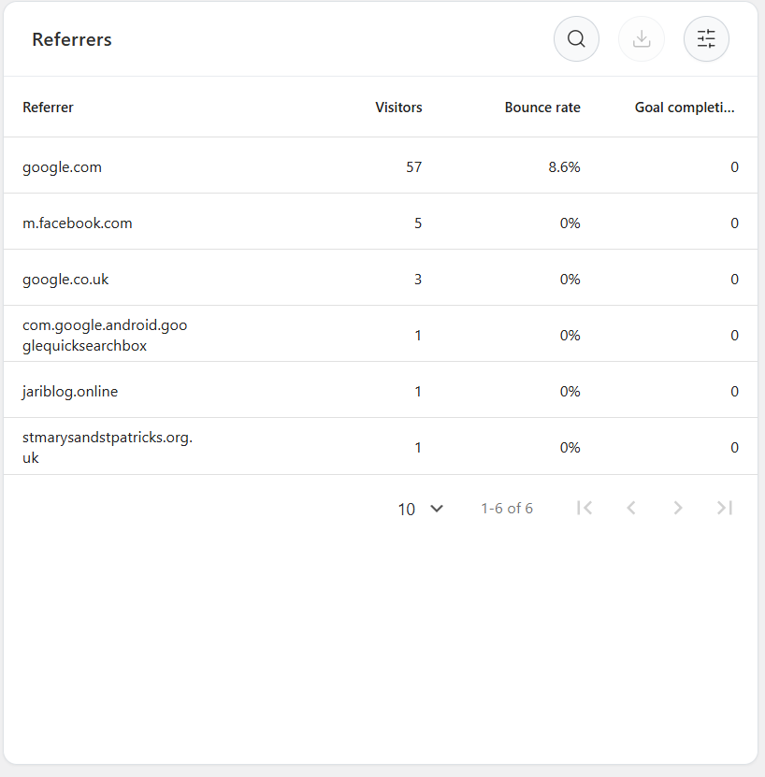

YouTube Stats Overall:
Subscribers – 23
Videos – 21. It’s been 5 months since last video uploaded.
Total views – 1,225
Most views: I Wanna Be Like You at Park Farm – 262
Bury Boogie at St Bernadettes – 191
Prestwich Carnival – Sweet Caroline - 147

